**3). Shell Scripting (File Organizer Shell Script)**

1) Created the directory and moved the directory into it and created required files.

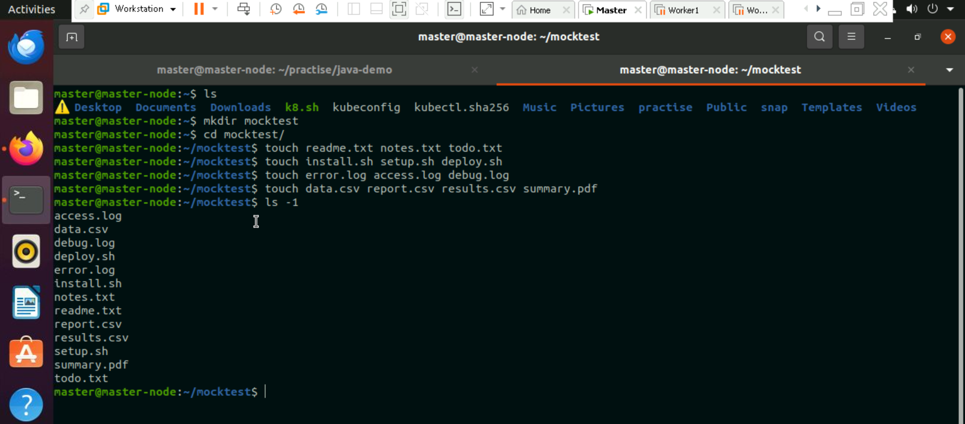

2) I have Created a filename with “file_organizer.sh” to write the script.



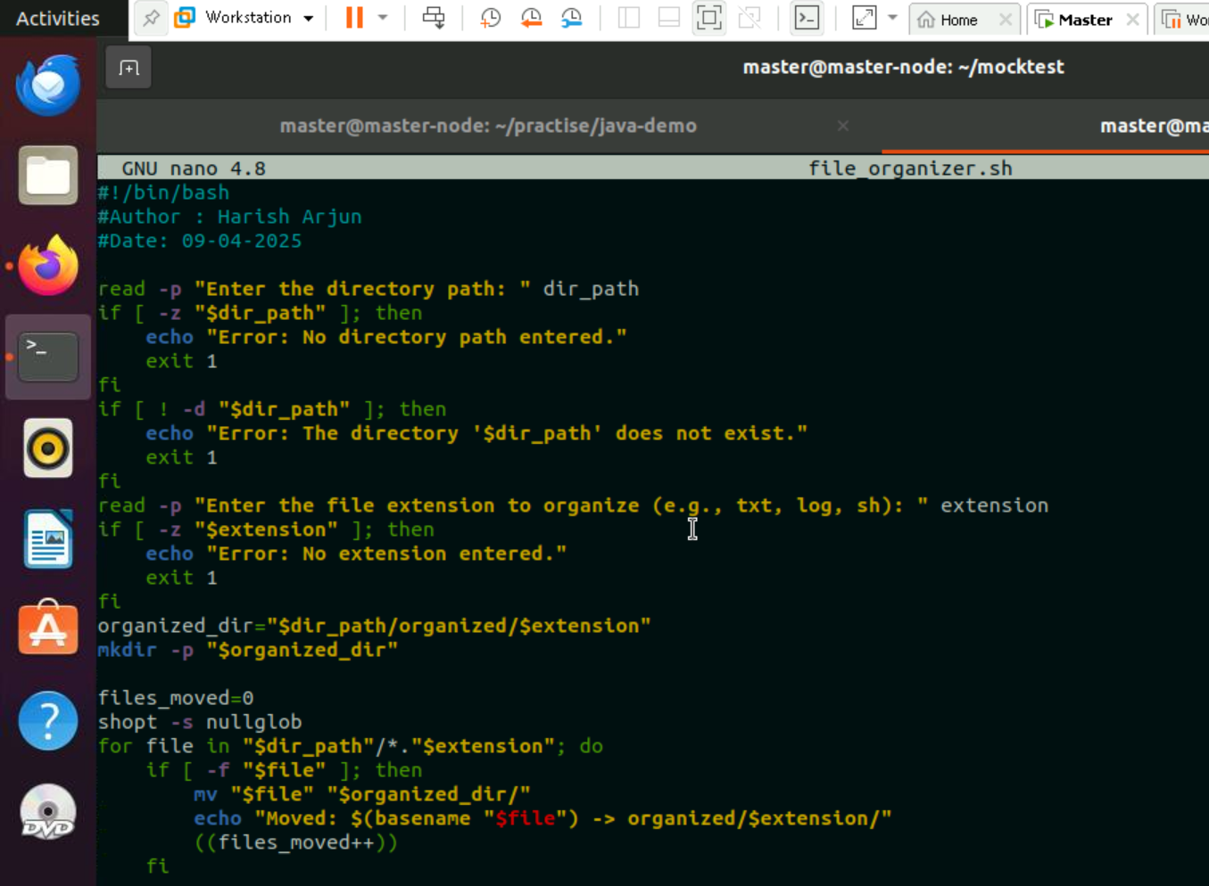



3)Give the Permissions to the file and run it.

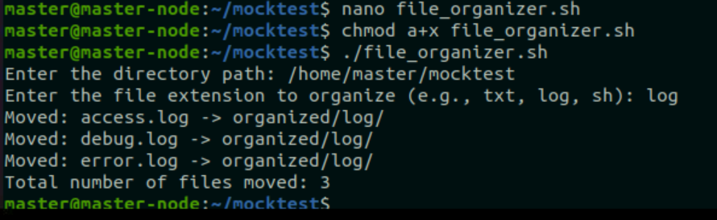

All the files created

